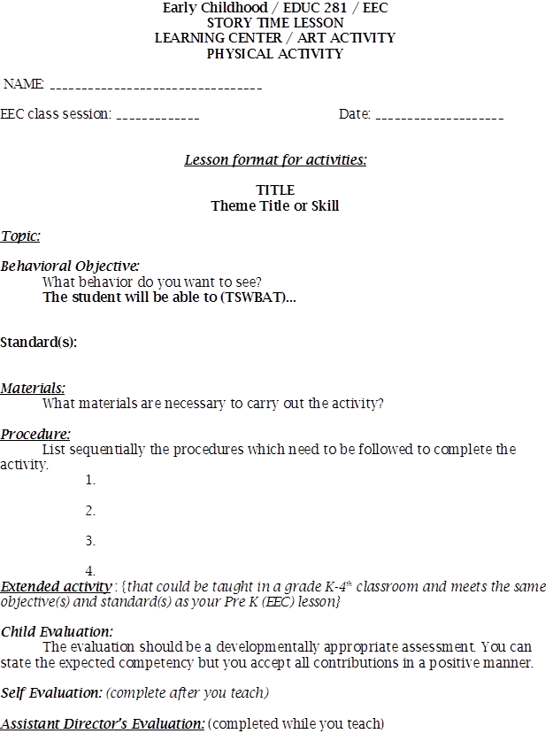
Natalie Slick
Story Time: The Tiny Seed By: Eric Carle
- The teacher will have all the students sit on a letter on the carpet, before introducing the story and who the author is.
- The teacher will read the story to students asking questions throughout such as: What do you think will happen to the seed next? Why did those seeds die? How are seeds that make it to soil in danger?
- Once the story is finished, the teacher will ask students the following: What do seeds need to survive to become flowers? Why did the one seed make it an others not?
Physical Activity: Flower Color Hop
- With a small group of students, the teacher will lay out pre-cut flowers in different colors randomly across the carpet.
- She will then instruct students that she will call out a color such as “Purple!” and students will have to find a purple flower and stand on it. Each time the color will change. When the color changes, students will have to hop (fly like a butterfly, crawl like a worm, etc.) to whatever colored flower the teacher calls. For example, if the students are standing on purple flowers and the teacher calls out “Hop like a bunny to a red flower!” students will have to hop to a red flower. The teacher will use a worksheet with scenarios on it while running this activity (see attached)
Art Activity: Sprout Houses
- The teacher will call 2-3 students over to the table to begin creating their Sprout House. She will hand each child a small zip-lock bag and a pre-cut paper Sprout House paper house (See attached).

Lima beans, plastic zip-lock bags, paper towels, water, a plastic cup, tape, 2 washable markers, pre-cute paper houses, The Tiny Seed by Eric Carle, and pre-cut construction paper flowers (purple, blue, green, yellow, red, orange).
TRAM
Standard - 4.1.PK.C Identify that plants need the sun to grow.
Standard - 4.1.K.E Identify how the changes of seasons affect their local environment.

The student will be able to recognize that sunlight helps plants to grow and that spring is a time for growth by growing seeds of their own. This will be done to the teacher’s satisfaction.
Spring- Seeds to Flowers
Exploring Flowers
Seasons- Spring
March 15th, 2016
- She will then instruct each child to write their name in marker next to the smiley face already written on their paper house.
- Once their name is on their paper house, the teacher will collect that houses until later. Then she will ask the students the following questions: Does anyone know what spring is? What is the weather like in spring? Students should answer that the weather is warm. Because it is warm outside, what grows outside? Students should answer that plants and flowers grow. What do plants need to grow? Students should answer water, sunlight, soil, etc.
- Now the teacher will hand each student a damp paper towel. She will explain to the students that they will be growing flowers of their own. The paper towels are going to be the soil and the water that the plant needs to grow.
- Next, the teacher will hand each student one lima bean seed that had been soaked in water the night before. She will have the students wrap the seed in the paper towel and place the paper towel with the seed in it inside the zip-lock bag.
- The teacher will then hand each student their Sprout House paper house back so they can tape it on top of their zip-lock bag.
- Once students have completed this, the teacher will explain that students will take their bag home and tape it to a window, so that the plant can get sunlight. Then they can watch and see how the seed grows into a plant.
- The teacher will emphasize the importance of how plants need the sun, water, and soil to grow. Without one, the plant will die.

Sprout House Observation Journal:
- The teacher could hang some of the sprout houses up on two windows in the classroom, one that got a lot of sunlight and one that did not get any sunlight. Once a week, she would have her students examine their sprout houses hanging in the window.
- Students would take a blank page in their notebooks and draw a picture of what their bean sprout looked like on that day.
- Underneath their picture, they would write what stage they thought the plant was in and any observations they noticed when examining their plant. Such as if there were roots, leaves, a stem, etc.
- At the end of the month, students would look back through this journal and see the progress their bean sprout plants went through or the lack of progress the bean sprout made, and thus the students could see how sunlight affects plant growth. Students would also see how the environment plays a factor in growth, which is why flowers grow in the spring and not winter.
Students will be able to provide characteristics of spring compared to other seasons, i.e. it is warmer out, there is not any snow, flowers grow, I do not have to wear a coat, etc. Students will also be able to explain that without sunlight, flowers will not be able to grow.
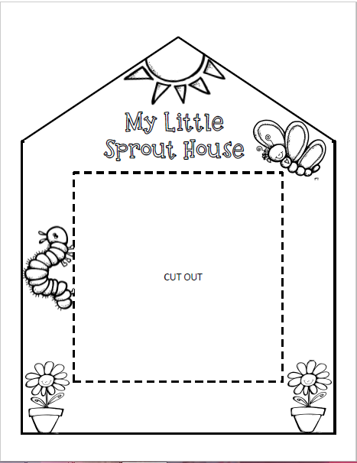

Flower Hop Directions
Have students hop from flower to flower based color. Use the following examples to call out to the students:
- HOP like a bunny to a RED flower.
- FLY like a butterfly to a PURPLE flower.
- DANCE like a bumble bee to a YELLOW flower.
- WIGGLE like a worm to a BLUE flower.
- CRAWL like a spider to a PINK flower.
- FLAP your wings like a ladybug to an ORANGE flower.

