The Lightning Thief
By Rick Riordan

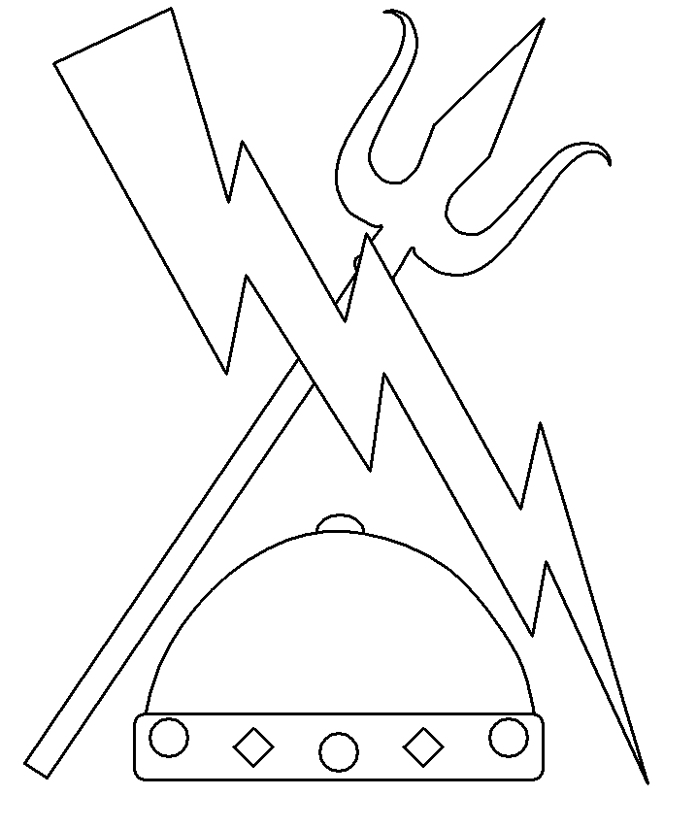

Name __________________________________

1

2
Vocabulary for The Lightning Thief
3
Word | Definition | Ch./Pg. # | Picture
- Ares
- Aphrodite
- Procrustes
- Charon
- Ghouls
- Chasm
- Tartarus
- Helm of Darkness
- Trident
- Kronos
Definition  Ghouls | Characteristics
Examples | Non- E Examples
4
Definition  Chasm | Characteristics
Examples | Non- E Examples
5

Tartarus

6
6
Helm of Darkness
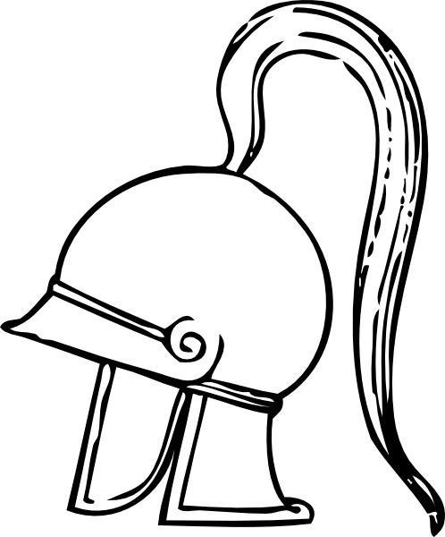
Write your definition of the word in the box below. Then decorate your own Helm of Darkness!

Definition:
7
7
Definition  Trident | Characteristics
Examples | Non- Ex Examples
8
Ares
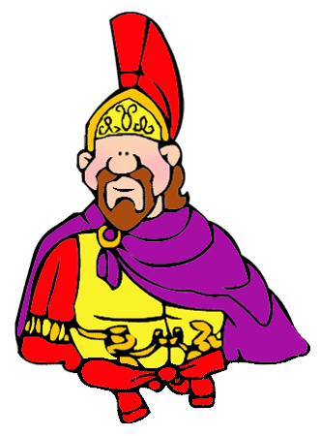

Home:________________________________________

Mini Bio: ____________________________________________________________________________________________________________________________________________________________________________________________________________________________________________________________________________________

Mortal or Immortal: ______________________________________________

Character Traits: ______________________________________________________________________________________________________________________________________________________________________________________________________________________________________

9
Aphrodite
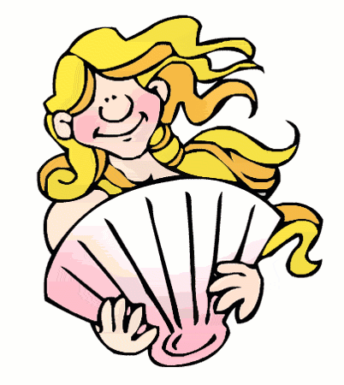

Home:________________________________________

Mini Bio: ____________________________________________________________________________________________________________________________________________________________________________________________________________________________________________________________________________________

Mortal or Immortal: ______________________________________________

Character Traits: ______________________________________________________________________________________________________________________________________________________________________________________________________________________________________

10
Procrustes
Home:________________________________________

Mini Bio: ____________________________________________________________________________________________________________________________________________________________________________________________________________________________________________________________________________________

Mortal or Immortal: ______________________________________________

Character Traits: ______________________________________________________________________________________________________________________________________________________________________________________________________________________________________

11
Charon
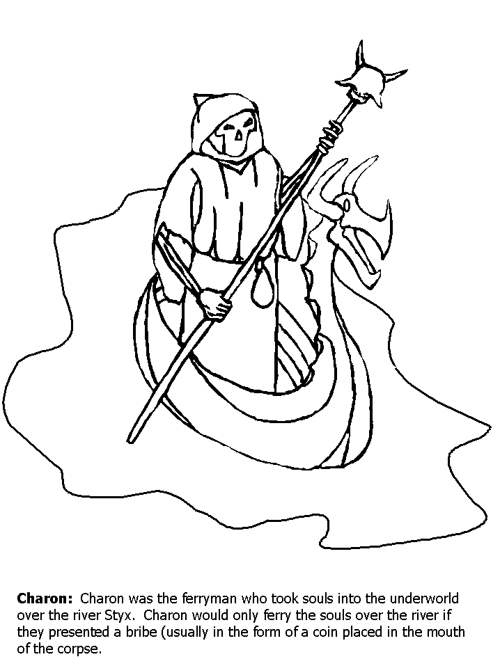
Home:________________________________________

Mini Bio: ____________________________________________________________________________________________________________________________________________________________________________________________________________________________________________________________________________________

Mortal or Immortal: ______________________________________________

Character Traits: ______________________________________________________________________________________________________________________________________________________________________________________________________________________________________

12
Kronos
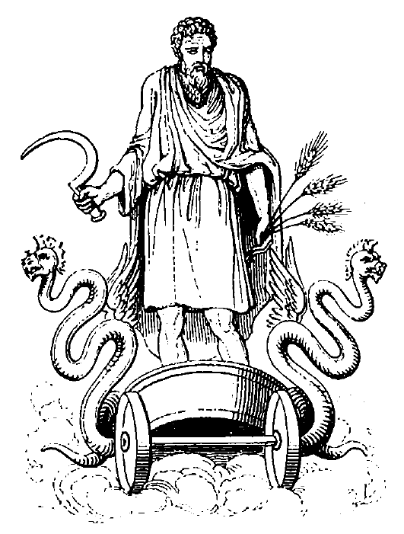
Home:________________________________________

Mini Bio: ____________________________________________________________________________________________________________________________________________________________________________________________________________________________________________________________________________________

Mortal or Immortal: ______________________________________________

Character Traits: ______________________________________________________________________________________________________________________________________________________________________________________________________________________________________

13
Identity Timeline
14
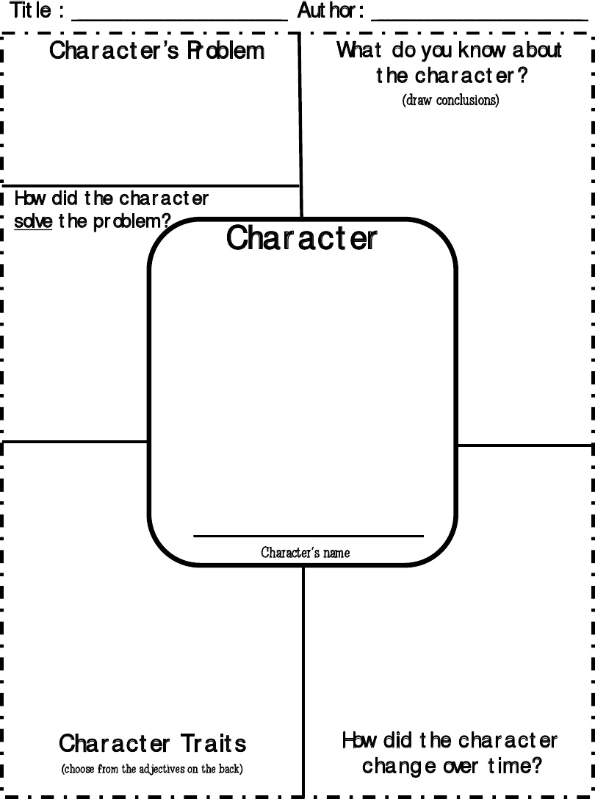
15
Ares- Greek God of War
Once during a great war, Ares was fighting against the Greeks, and driving them all before him. When Athena saw this, she went to their aid; for she thought that they had been right in the quarrel which had begun the war, and she did not wish to see them defeated. When Ares saw her upon the Greek side in all her armor, he rushed toward her, and threw his terrible spear against her breast. Athena caught the spear point on her shield, and turned it aside. Then she seized a great rock, and hurled it at Ares. Her aim was so sure that it struck him squarely, and knocked him flat upon his back. He was such an enormous fellow that it was said that his body covered seven acres as he lay there on the ground. Ares was so injured by the blow, that he gave up the fight, and fled to Mount Olympus. Then the Greeks, with the help of Athena, won the victory.
The Greeks loved to tell another story about the way in which Ares was once made prisoner. Long, long ago, they said, two boys were born who were named Otus and Ephialtes. At first they were small and weak, but they grew so rapidly that they soon astonished all men by their size and beauty. When they were yet only nine years old, they had become giants many feet tall, and they were as brave as they were huge. Now, these giants were farmers, and loved to live in peace, and care for their growing grain. But Ares stirred up such constant war among men that their crops were often destroyed, and their fields laid bare.
At last Otus and Ephialtes became very angry at this, and determined to see what they could do to stop it. They were so strong and brave that they had no fear of Ares at all; so they planned and planned, and one day succeeded in taking the war-god prisoner. Then, in order to keep him securely, they put him in a great bronze vase. After this, for thirteen months, there were no wars, and their grain fields were undisturbed In spite of all he could do, Ares could not get out; and indeed, he might have had to stay there forever if Hermes had not discovered what had become of him, and set him free.
16
17

18
Ch. 14/15 Journal Entry
Create a poster below that could be hung in front of the river by the St. Louis Gateway Arch to help stop people from polluting the water. Make sure to include why pollution is so bad.
19
Theseus and Procrustes
Theseus was the son of the king of Athens, King Aegeus. He showed great strength as a boy and later becomes a well-known hero. The Greeks saw their heroes and gods as powerful beings who had much in common with human beings.

Theseus went on a journey to Athens, where he was asked to travel to help with the horrible robbers and bandits that had in habited the road. On part of his journey to Athens, Theseus met Procrustes.

Procrustes (proh-KRUS-teez), whose name means “he who stretches,” was arguably the most interesting of Theseus’s challenges on the way to becoming a hero. Theseus fought Procrustes, a wicked innkeeper, who lived beside the main road and kept only one bed in his inn. Procrustes offered hospitality to passing strangers, who were invited in for a pleasant meal and a night’s rest in his very special bed. Procrustes described it as having the unique property that its length exactly matched whoever lay down upon it. What Procrustes didn’t volunteer was the method by which this “one-size-fits-all” was achieved, namely as soon as the guest lay down Procrustes went to work upon him, stretching him on the rack if he was too short for the bed and chopping off his legs if he was too long. If the traveler was the right size, Procrustes would smother them with a blanket.

Theseus turned the tables on Procrustes, fatally adjusting him to fit his own bed. Theseus wrapped the dead body in a blanket and threw it into the sea.

20

Lessons Learned
List important lessons Percy learns on his quest below.

21
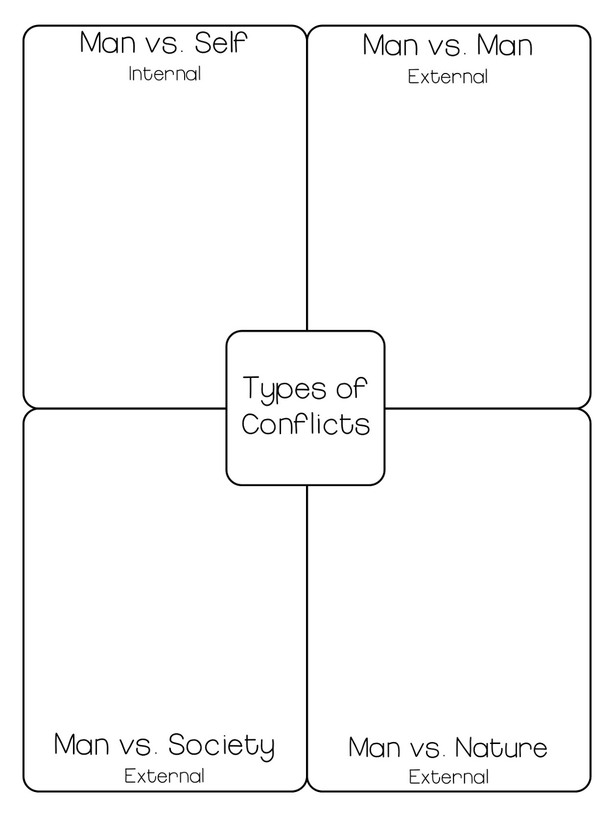
22
Ch. 16/17 Journal Entry
Retell Percy’s nightmare in the space below (pg. 252-254)
First,______________________________________________________________________________________________________________________________________________________________________________________________________________________________________________________________________________________________Then,_____________________________________________________________________________________________________________________________________________________________________________________________________________________________________________________________________________________________Next,___________________________________________________________________________________________________________________________________________________________________________________________________________________________________Then,_________________________________________________________________________________________________________________________________________________________________________Last,__________________________________________________________________________________________________________________________________________________________________________Finally,________________________________________________________________________________________________________________________________________________________________________
23
Charon- The Ferryman of the Underworld

No one knows much about the River Styx, no one alive that is. The Styx was a special river. To the ancient Greeks, the River Styx separated the world of the living from the world of the dead.
As the story goes...When your soul reached the River Styx, a boatman named Charon would give you a ride to the underworld. But the ride was not free. If your family had not buried you with a coin to use as payment, you were stuck. Some souls, who did not have a coin, tried to swim across the River Styx. Some made it. Most didn't.
For those souls who received a ride in Charon's boat, or managed to swim across the river, there was little to do on the other side except wait to be reborn into a new body. These souls would not remember their prior life. They would start over as an infant. So, unlike the ancient Egyptians, the ancient Greeks didn't spend a lot of time planning for their afterlife because they did not expect to be there very long.
According to Greek mythology, some people were shocked to discover that they would be stuck there for some time, in some cases, forever. Some souls were sent to the Underworld as punishment. For others, it seemed to take quite a while to find just the right body. The Underworld was not packed, but it was populated.
24
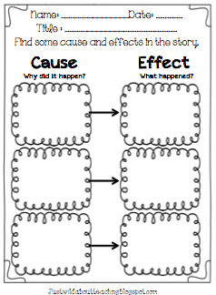
25
Ch. 18 Journal Entry
Imagine you had to convince Charon to give you a ride on his boat. How would you convince him to let you ride with him?
________________________________________________________________________________________________________________________________________________________________________________________________________________________________________________________________________________________________________________________________________________________________________________________________________________________________________________________________________________________________________________________________________________________________________________________________________________________________________________________________________________________________________________________________________________________________________________________________________________________________________________________________________________________________________________________________________________________________________________________________________________________________________________________________________________________________________________________________________________________________________________________________________
26

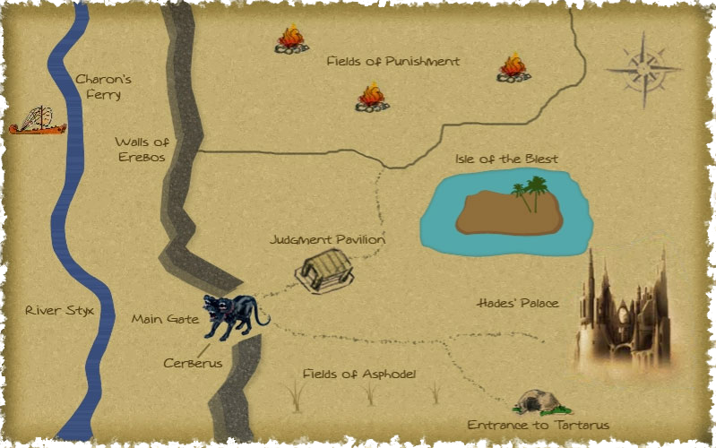

Map of the Underworld
27
28

29
Ch. 19 Journal Entry
If you had a helm of darkness of your own, what would you do with it?
________________________________________________________________________________________________________________________________________________________________________________________________________________________________________________________________________________________________________________________________________________________________________________________________________________________________________________________________________________________________________________________________________________________________________________________________________________________________________________________________________________________________________________________________________________________________________________________________________________________________________________________________________________________________________________________________________________________________________________________________________________________________________________________________________________________________________________________________________________________________________________________________________
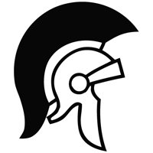
30
Kronos and Rhea
According to Greek mythology, in the beginning there was nothing. This was called Chaos. From this nothingness came light, Mother Earth (Gaia) and Sky (Uranus) were formed. From Gaia and Uranus came six twins known as the Titans. The six twin Titans were named Oceanus and Thethys, Coeos and Phoebe, Hyperion and Thea, Creos and Themis, Lapetos and Clymene, and finally Kronos and Rhea.
After defeating his father, Kronos married his sister Rhea. The two had six children: Hestia, Demeter, Hera, Hades, Poseidon and Zeus. Kronos, after each birth, swallowed the first five children because of a prophecy that claimed one of his children would overthrow him. Rhea tricked Kronos with the sixth child. Zeus, instead of handing Kronos the child, she gave him a rock in a blanket. Kronos swallowed it believing it was the baby. Rhea then smuggled the baby Zeus to the island of Crete to be raised by nymphs. Later Zeus would return to defeat his father in the battle between the Olympians and the Titans.
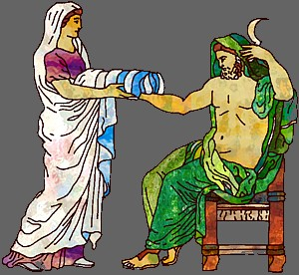

31
Ch. 20/21 Journal Entry
Write a postcard home to your parents below and tell them about one of your favorite parts of the story so far. Include a picture of this part too!

32
Vocabulary Review
Write a sentence using the bolded word.
- Tartarus
________________________________________________________________________________________________________________________________
- Ghouls
________________________________________________________________________________________________________________________________
- Trident
________________________________________________________________________________________________________________________________
- Helm of Darkness
________________________________________________________________________________________________________________________________
- Chasm
________________________________________________________________________________________________________________________________

Match each letter description to a Greek god/goddess.

1. ____ Ares
2. ____ Aphrodite
3. ____ Procrustes
4. ____ Kronos

- Goddess of beauty and love
- Robber who made people fit his bed.
- God of war
- Ruler of the gods. Imprisoned in Tartarus
33

Ch. 22 Journal Entry
How did you like the story? Would you read it again, why or why not? What do you think will happen next to Percy?
________________________________________________________________________________________________________________________________________________________________________________________________________________________________________________________________________________________________________________________________________________________________________________________________________________________________________________________________________________________________________________________________________________________________________________________________________________________________________________________________________________________________________________________________________________________________________________________________________________________________________________________________________________________________________________________________________________________________________________________________________________________________________________________________________________________________________________________________________________________________________________________________________

34
FINAL PROJECT – PAMPHLET
For your final project in this novel unit, you will be creating a Lightning Thief Camp Half-Blood Summer Camp Pamphlet which contains the highlights of the information that we will be discussing and working through as a group throughout the two weeks. This pamphlet will be used to convince other half-bloods to come to Camp Half-Blood. This pamphlet will also act as a final “book report” and a place for you to demonstrate your knowledge and understanding of the novel. The majority of this information will already be in your camper notebooks and you will simply have to make it fit the criteria.
1. Welcome to Camp Half-Blood. (Front Flap)
-Create a heading for Camp Half-Blood. Write the title of the book, the author, and draw a picture of the book’s cover. DON’T forget your name!
2. Lessons Learned (Inside Right Flap when first open)
-Make a list of the most important lessons Percy learned throughout the novel.
3. The Quest (Inside Left Flap)
-Choose your favorite conflict from the novel and draw a picture of the event in the open space. Label which of the four types of conflict it is categorized as a write a brief description of what happened and how it problem was resolved in the end.
4. Camper of the Week (Inside Right Flap)
-Choose your favorite character from the novel and draw a picture of him/her in the open space. Write the character’s name, their most important character traits, and why they are your favorite.
5. Theme (Inside Middle)
-Identify the most important theme of the book in your opinion and write a few sentences about how the author developed the theme throughout the novel and which main events contributed towards it.
6. Setting (Back Panel)
-Choose 1 place that Percy visited and describe it. Explain briefly what happened to Percy there and draw a picture of the place.
This project is worth 50 points and graded on completion, detail, accuracy, and thoughtfulness of each section.
35

