Subject Matter Research # 2
Topic: Migration

Part One (Adult Explanation)
Through my research, I learned that many different animals migrate to escape colder climates. Two of the longest migrations are the humpback whale and monarch butterflies’, who migrate yearly. Some animals migrate because of lack of resources in the previous area, for raising new offspring, and for warmer climates due to the inability to defend themselves from the cold. Scientists are not sure how these animals know exactly where to go for these migrations because they go to the same spot every year, but some speculate that it is a part of their genetics. Others say it is caused by learned geography landmarks that cue them to the correct spot. After years of doing the same route, eventually the animals just know where to go. Natural selection has helped to refine these journeys by allowing animals to find the best currents (wind, water) to make their journeys faster and more efficient. This does not diminish the fact that often times these migrations are treacherous, but for the animals the benefits of migrating out-weigh the consequences of a difficult journey.
Part Two (Prior Knowledge)
- Prior Knowledge/Life Experience: It is likely that students have heard of the word migration before but may not know exactly what it entails. They may have also heard of birds flying south for the winter. We will expand on this prior knowledge and correct any misconceptions as we discuss migration.
- Day One: Students learned that camouflage is a physical adaptation animals use to survive and thrive in cold environments. This knowledge is important because not all animals have camouflage. By knowing this, students will be able to see that some animals have to migrate because they do not have the adaptations to stay in their current location.
- Day Two: Students learned that animals have different adaptations to keep them warm when it gets cold outside. This is important to today’s lesson because not all animals have fat (like blubber) or special feathers to repel water. Because of this, we can explain that these animals have to migrate to find better food sources and to stay warm.
- Day Three: Student learned about adaptations animals use to protect themselves and to find food. This is important because although some animals who migrate may have some of these adaptations, they may not be able to use them in cold climates or there may not be resources for them to gather food, which is why many animals migrate to warmer areas.
- Day Four: Students learned about hibernation. This is important because although some animals can hibernate, not all animals can do this. The animals who cannot hibernate and sleep off the cold may migrate in order to survive.
Part Three (Future Knowledge)
- Day Six: The students will be informally assessed on their understanding of the information that was taught in this unit through review games. It will not count as a grade.
- Future Learning: This knowledge is important for the future so that students can make sense of their environment by learning how animals deal with climate change. It is essential that students see these processes as important because climate change causes these processes to occur and if the climate changes due to pollution these animals will have to readapt or may die off as a species.
Part Four (Resources Used)
- http://www.livescience.com/10235-animals-migrate.html
- http://www.nature.com/scitable/knowledge/library/animal-migration-13259533

- Topic: The topic of this second grade science lesson is animal migration during winter. The students will discover why animals decide to go to other areas of the world during the winter.
  - Vocabulary:
    - Migration: to move from one area to another at different times of the year.
- Objective(s):
  - Given class discussion and the geese migration game, TSWBAT explain why animals decide to migrate in the winter and some of the sacrifices these animals make in order to change climate.
- Standard(s): PA Environment and Ecology- 4.1.2.E Identify how living things survive changes in their environment.
- Teaching Procedures:
  - Anticipatory Set: (3 minutes) I will label one end of the classroom with a sign that says “north” and the other “south.” (See Below). I will explain to students that they are going to pretend that they are birds. They are going to fly from one end of the classroom to the other. I will explain that the “north” (where we are starting) is too cold and there is not any food for us to eat, so we are going to travel to the “south” because it is warmer and there is more food there. Students will pretend to fly from one end of the classroom to the other. I will remind students to walk. Once we make it to the “south” (the carpet in the front of the room). I will ask students what they think it is called when animals move from one place to another. After hearing student responses, I will explain that what we just did is called migration.
  - Development 1: (15 minutes) I will use the quiet signal to get student attention if they have a difficult time calming down after the anticipatory set. I will explain that the last couple of days we have been learning about adaptations and that yesterday we learned about hibernation, which is an adaptation some animals use to survive the winter. I will ask students what they think animals who do not have these adaptations or do not hibernate, do during the winter. I will explain that these animals migrate from one place to another. I will then pull up a map on the Promethean board that shows dots that represent animals migrating across North and South America. (https://www.allaboutbirds.org/mesmerizing-migration-watch-118-bird-species-migrate-across-a-map-of-the-western-hemisphere/) I will explain that the dots change color to show different days the animals traveled. I will then ask students why they think animals migrate during the winter. We will brainstorm a list of ideas. I will pose questions such as: Do you think there is more food for animals during the winter when it snows or during the spring and summer when it is warm and plants grow? Do you think animals would want to raise their babies in a place without a lot of food? Do you think animals who migrate have blubber like whales or have white fur that blends in with the snow like a polar bear? I will then show students a video clip that explains why animals migrate to reinforce our list of ideas (http://viewpure.com/USOasz_zq_I?start=0&end=0) I will stop the video throughout and ask students what reason the video stated for why animals migrate.
  - Guided Practice 1: (10 minutes) I will have the students sit in a circle on the carpet. I will then explain that now we are going to play a game that will teach us about geese migration and some of the challenges geese go through when they fly to a new place. Although there are many animals who migrate and face a lot of challenges, for this game we are going to see what geese go through. Many of the things that they go through, other birds and animals also go through. I will then pick a student volunteer to be my partner for the game. My partner will be a student who is having difficulty paying attention or whom I think may benefit from extra practice of the game. I will model for the class how to play the game (See below). With my partner, I will roll the die. The number that the die shows, is the number of spaces my game piece (a coin) moves. Every time I roll the die, I also have to pick up a game card. Depending on what the card says, my game piece either moves forward or backwards. The first person to get to the finish line is the winner and successfully migrated.
  - Independent Practice: (15 minutes) After modeling the game to the students, I will pick their partners and direct them to find a quiet space around the room to play the game. I will remind them not to pick a spot too close to another group or a place where they think they might get distracted. I will circulate around the room and make sure that all the students are following the rules and are understanding the game. I will assist any students who need help.
  - Closure: (2 minutes) I will use the quiet signal to get students’ attention in order to bring them back to the carpet for the closure. I will have students discuss their experiences playing the game. Was it challenging, frustrating, fun, etc.? What challenges did the geese face while migrating? Did anything surprise you? Now what are some reasons that animals decide to migrate in the winter?
- Materials
- North and South signs
- Promethean board
- Video clips/Interactive map
- Dry erase marker
- Easel
- Dice
- Geese Migration board game and cards
- Coins
- Adaptations/Plan Modifications: I will pick Markel or a student I believe is easily distracted or may not understand the game to be my partner during the guided practice. I will also make sure to circulate more often to students who are easily distracted or have difficulty with the concept of migration. I will also pair these students with students who seem to have a firm grasp on the concept of migration. If we have extra time, I will have the students play the game another time. I may also pull up an extra video clip of animals migrating (such as the monarch butterflies). If we are short on time, I will reduce brainstorming time and make the amount of time students play the game shorter.
- Evaluation:
  - Formative: Throughout the class discussion/brainstorming, I will evaluate students’ understanding of migration through student responses. I will also determine if students are understanding the concept by circulating during the independent practice. Finally, during the closure I will be able to clarify things students still do not understand, as well as see who really grasped the lesson and who did not.
  - Summative: None.
- Reflection:

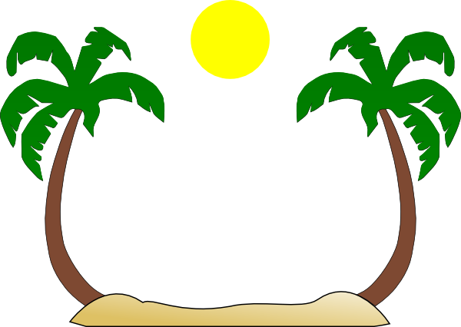

South

North

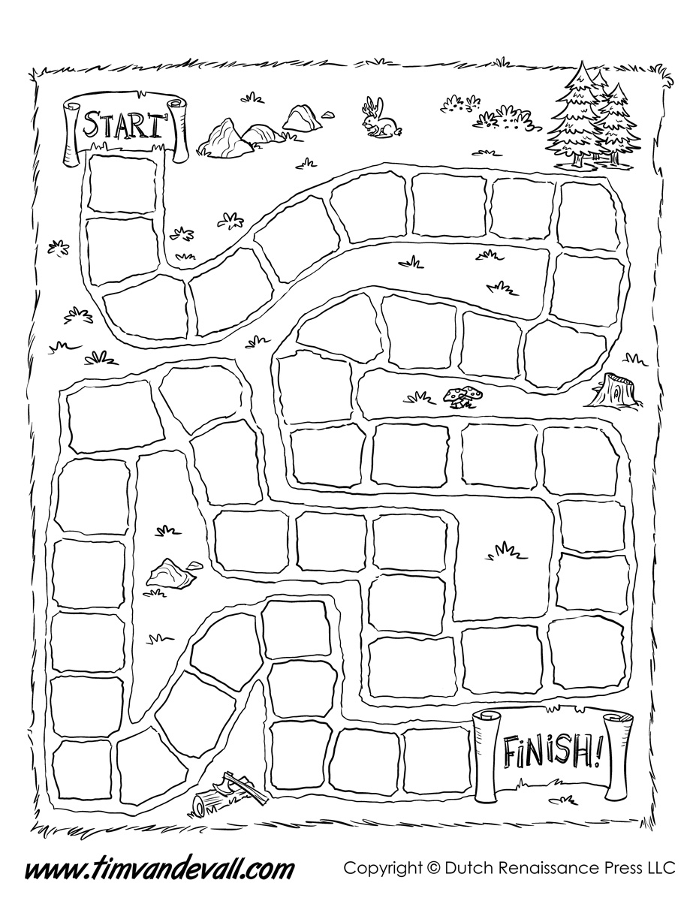

Find a shortcut, skip four spaces. | Hit a window, go back one space.
Run out of food, miss your next turn. | Found a strong air current, roll again.
Hurt your wing, lost a turn. | Had a good night sleep, go ahead 2 spaces.
Missed your stop, lose a turn. | Flew extra fast, go ahead 4 spaces.
Ate bad food, lose a turn. | Met some friends, roll again.
Got lost, go back two spaces.

