- Which of the following is a producer?
- A fox b. A butterfly c. A tree

- Which of the following is an omnivore?
- A bear b. An Owl c. A flower

- Which of the following is a carnivore?
- Grass b. A zebra c. An Owl

- What does a decomposer eat to get energy?
- Sunlight b. Dead plants/animals c. Air

- Name an example of a habitat.

6-11. Create 2 food chains using the animal pictures.

12. (Bonus) What type of consumer is a human?
a. Carnivore b. Omnivore c. Herbivore d. Decomposer

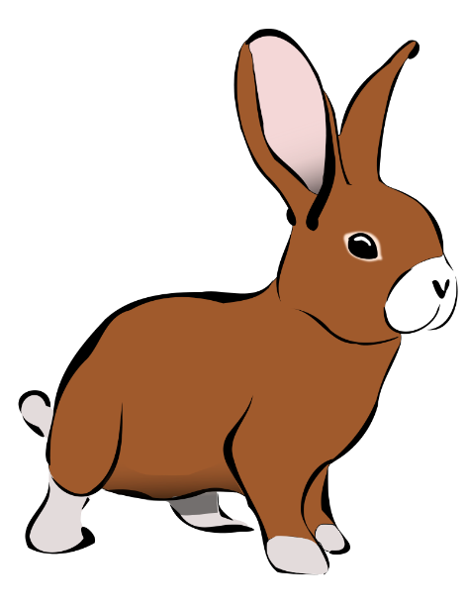

Carrots Rabbit
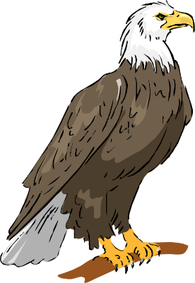

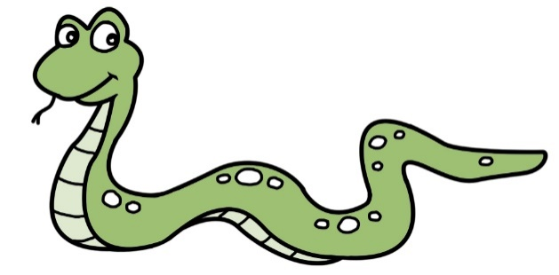

Snake Eagle
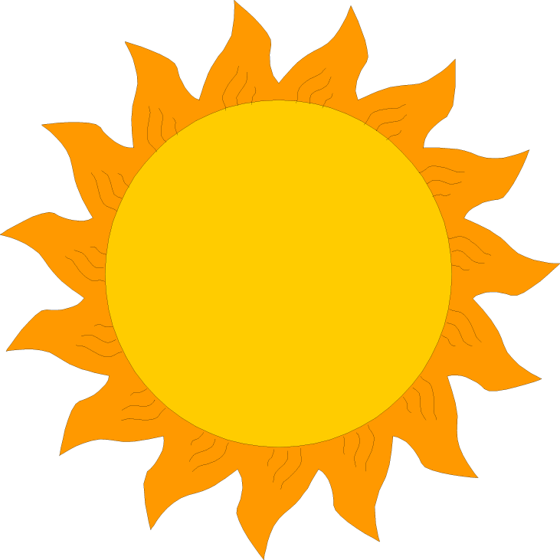

Sun Grass

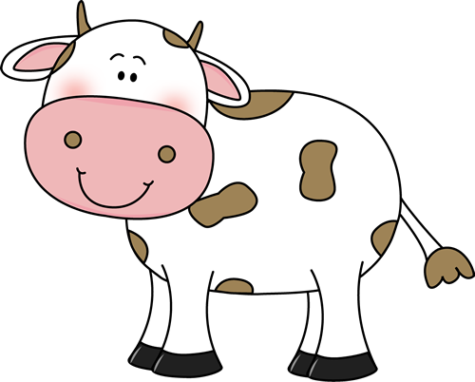

Cow Humans

